Practical-1

Objective: Write the algorithm of Linear Search.
Algorithm:
BEGIN

FUNCTION generateRandomNumber(arr, n)
FOR i ← 0 TO n - 1 DO
arr[i] ← RANDOM number between 0 and 9999
END FOR
END FUNCTION

FUNCTION linearSearch(arr, n, key)
FOR i ← 0 TO n - 1 DO
IF arr[i] = key THEN
RETURN i
END IF
END FOR

RETURN -1
END FUNCTION

MAIN

DECLARE n

PRINT "Enter the size of the array:"
INPUT n

IF n < 10 THEN
PRINT "Please enter a number greater than or equal to 10."
EXIT
END IF

Allocate memory for array arr of size n

IF memory allocation fails THEN
PRINT "Memory not allocated."
EXIT
END IF

Initialize random number generator

CALL generateRandomNumber(arr, n)

randomIndex ← RANDOM number between 0 and n - 1
key ← arr[randomIndex]

PRINT "Key selected for searching:", key
PRINT "Original index of key:", randomIndex

start ← current clock time

FOR i ← 1 TO 1000 DO
result ← linearSearch(arr, n, key)
END FOR

end ← current clock time

time_taken ← (end - start) / CLOCKS_PER_SECOND / 1000

PRINT "Key found at index:", result
PRINT "Average time taken for linear search:", time_taken

Free memory allocated for arr

END

Code:
//-----------LINEAR SEARCH------------//

#include <stdio.h>
#include <stdlib.h>
#include <time.h>

void generateRandomNumber(int arr[], int n)
{
for (int i = 0; i < n; i++)
{
arr[i] = rand() % 10000;
}
}

int linearSearch(int arr[], int n, int key)
{
for (int i = 0; i < n; i++)
{
if (arr[i] == key)
{
return i;
}
}
return -1;
}

int main()
{
int n;

printf("Enter the size of the array: ");
scanf("%d", &n);

if (n <10)
{
printf("Please enter a number greater than or equal to 10.\n");
return 0;
}

int *arr = (int *)malloc(n * sizeof(int));

if (arr == NULL)
{
printf("Memory not allocated.\n");
return -1;
}

srand(time(NULL));

generateRandomNumber(arr, n);

// Select a random key from the array
int randomIndex = rand() % n;
int key = arr[randomIndex];

// Display the key and its original index
printf("\nKey selected for searching: %d\n", key);
printf("Original index of key: %d\n", randomIndex);

clock_t start = clock();

int result;
for (int i = 0; i < 1000; i++)
{
result = linearSearch(arr, n, key);
}

clock_t end = clock();

double time_taken = ((double)(end - start)) / CLOCKS_PER_SEC / 1000.0;

printf("Key found at index: %d\n", result);
printf("Average time taken for linear search in %d elements: %lf seconds\n",
n, time_taken);

free(arr);

return 0;
}

Output:
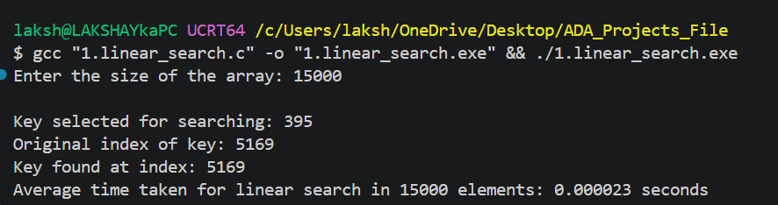

Table:
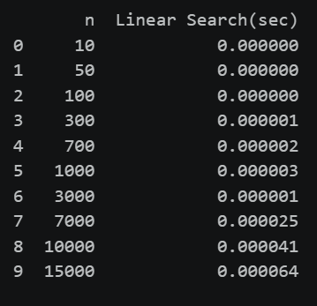

Graph:
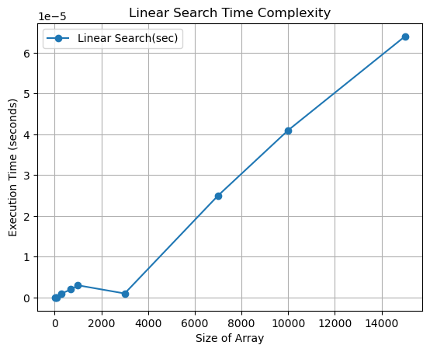
Conclusion:
The graph shows that the execution time of Linear Search generally increases as the size of the array increases. This indicates a linear relationship between input size and execution time, which agrees with the theoretical time complexity of O(n).
For smaller array sizes, the execution time is very small and shows some fluctuations due to factors such as system overhead, CPU scheduling, and timer precision. However, as the array size becomes larger (around 3,000 to 15,000 elements), the increasing trend becomes much clearer.
Therefore, the experimental results support the theoretical conclusion that Linear Search has a time complexity of O(n) in the average and worst cases.

Practical-2
Objective: Write the algorithm of Binary Search.
Algorithm:
BEGIN

FUNCTION compare(a, b)
RETURN a - b
END FUNCTION

FUNCTION generateRandomNumber(arr, n)
FOR i ← 0 TO n - 1 DO
arr[i] ← RANDOM number between 0 and 9999
END FOR
END FUNCTION

FUNCTION binarySearch(arr, n, key)

low ← 0
high ← n - 1

WHILE low ≤ high DO

mid ← low + (high - low) / 2

IF arr[mid] = key THEN
RETURN mid

ELSE IF arr[mid] < key THEN
low ← mid + 1

ELSE
high ← mid - 1
END IF

END WHILE

RETURN -1

END FUNCTION

MAIN

DECLARE n

PRINT "Enter the size of the array:"
INPUT n

IF n < 10 THEN
PRINT "Please enter a number greater than or equal to 10."
EXIT
END IF

Allocate memory for array arr of size n

IF memory allocation fails THEN
PRINT "Memory not allocated."
EXIT
END IF

Initialize random number generator

CALL generateRandomNumber(arr, n)

Sort arr in ascending order using quick sort

randomIndex ← RANDOM number between 0 and n - 1
key ← arr[randomIndex]

PRINT "Key selected for searching:", key
PRINT "Original index of key:", randomIndex

start ← current clock time

FOR i ← 1 TO 1000 DO
result ← binarySearch(arr, n, key)
END FOR

end ← current clock time

time_taken ← (end - start) / CLOCKS_PER_SECOND / 1000

PRINT "Key found at index:", result
PRINT "Average time taken for binary search:", time_taken

Free memory allocated for arr

END

Code:
//-----------BINARY SEARCH------------//

#include <stdio.h>
#include <stdlib.h>
#include <time.h>

int compare(const void *a, const void *b)
{
return (*(int *)a - *(int *)b);
}

void generateRandomNumber(int arr[], int n)
{
for (int i = 0; i < n; i++)
{
arr[i] = rand() % 10000;
}
}

int binarySearch(int arr[], int n, int key)
{
int low = 0;
int high = n - 1;

while (low <= high)
{
int mid = low + (high - low) / 2;

if (arr[mid] == key)
{
return mid;
}
else if (arr[mid] < key)
{
low = mid + 1;
}
else
{
high = mid - 1;
}
}

return -1;
}

int main()
{
int n;

printf("Enter the size of the array: ");
scanf("%d", &n);

if (n < 10)
{
printf("Please enter a number greater than or equal to 10.\n");
return 0;
}

int *arr = (int *)malloc(n * sizeof(int));

if (arr == NULL)
{
printf("Memory not allocated.\n");
return -1;
}

srand(time(NULL));

generateRandomNumber(arr, n);
qsort(arr, n, sizeof(int), compare);

// Select a random key from the array
int randomIndex = rand() % n;
int key = arr[randomIndex];

// Display the key and its original index
printf("\nKey selected for searching: %d\n", key);
printf("Original index of key: %d\n", randomIndex);

clock_t start = clock();

int result;
for (int i = 0; i < 1000; i++)
{
result = binarySearch(arr, n, key);
}

clock_t end = clock();

double time_taken = ((double)(end - start)) / CLOCKS_PER_SEC / 1000.0;

printf("Key found at index: %d\n", result);
printf("Average time taken for binary search in %d elements: %lf seconds\n",
n, time_taken);

free(arr);

return 0;
}

Output:
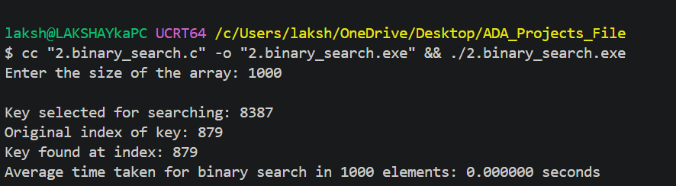
Table:
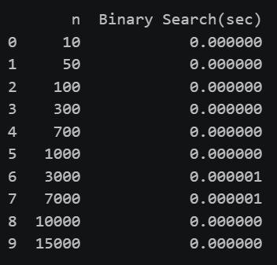
Graph:
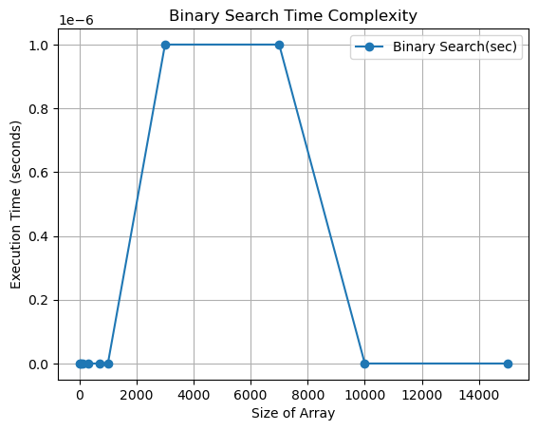

Conclusion:
The graph shows that the execution time of Binary Search remains extremely small and does not increase consistently with the size of the array. Even when the array size increases up to 15,000 elements, the execution time stays around 0 to 1 × 10⁻⁶ seconds.
This behaviour is expected because Binary Search reduces the search space by half after every comparison, giving it a theoretical time complexity of O(log n). The irregular jumps and drops in the graph are mainly due to the very small execution times, timer precision, and system-related variations rather than the actual complexity of the algorithm.
Therefore, the experimental results support the theoretical conclusion that Binary Search has a logarithmic time complexity, O(log n), in the average and worst cases.

Practical-3
Objective: Analysing the algorithm of insertion sort.
Algorithm:
INSERTION_SORT(A, n)

for i ← 1 to n - 1

key ← A[i]
j ← i - 1

while j ≥ 0 AND A[j] > key

A[j + 1] ← A[j]
j ← j - 1

A[j + 1] ← key

return A
Code:
//-----------INSERTION SORT------------//

#include <stdio.h>
#include <stdlib.h>
#include <time.h>

void generateRandomNumber(int arr[], int n)
{
for (int i = 0; i < n; i++)
{
arr[i] = rand() % 10000;
}
}

void insertionSort(int arr[], int n)
{
for (int i = 1; i < n; i++)
{
int key = arr[i];
int j = i - 1;

while (j >= 0 && arr[j] > key)
{
arr[j + 1] = arr[j];
j--;
}
arr[j + 1] = key;
}
}

int main()
{
int n;

printf("Enter the size of the array: ");
scanf("%d", &n);

if (n < 10)
{
printf("Please enter a number greater than or equal to 10.\n");
return 0;
}

int *arr = (int *)malloc(n * sizeof(int));

if (arr == NULL)
{
printf("Memory not allocated.\n");
return -1;
}

srand(time(NULL));
generateRandomNumber(arr, n);

clock_t start = clock();

insertionSort(arr, n);

clock_t end = clock();

double time_taken = ((double)(end - start)) / CLOCKS_PER_SEC ;

printf("Insertion sort completed for %d elements.\n", n);
printf("Average time taken for insertion sort: %lf seconds\n", time_taken);

free(arr);

return 0;
}
Output:
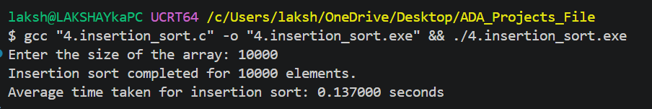
Table:
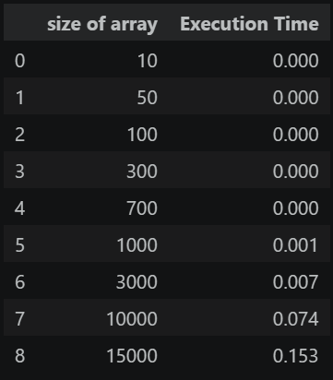

Graph:
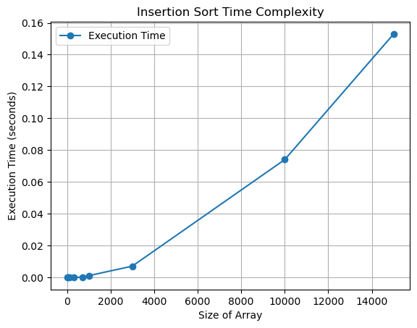

Conclusion:
The graph shows that the execution time of Insertion Sort increases significantly as the size of the array increases. For smaller input sizes, the execution time is very low, but it rises rapidly for larger arrays, reaching approximately 0.15 seconds at 15,000 elements.
This increasing trend indicates that Insertion Sort becomes considerably slower as the input size grows, which is consistent with its theoretical O(n²) time complexity in the average and worst cases. The slight fluctuations for smaller array sizes can be attributed to system overhead, CPU scheduling, and timer precision.
Therefore, the experimental results support the theoretical conclusion that Insertion Sort has a quadratic time complexity, O(n²), making it less efficient for large datasets.

Practical-4

Objective: Analysing the algorithm of merge sort.
Algorithm:
MERGE_SORT(A, low, high)

if low < high

mid ← (low + high) / 2

MERGE_SORT(A, low, mid)

MERGE_SORT(A, mid + 1, high)

MERGE(A, low, mid, high)

MERGE(A, low, mid, high)

Create temporary array TEMP

i ← low
j ← mid + 1
k ← 0

while i ≤ mid AND j ≤ high

if A[i] ≤ A[j]

TEMP[k] ← A[i]
i ← i + 1

else

TEMP[k] ← A[j]
j ← j + 1

k ← k + 1

while i ≤ mid

TEMP[k] ← A[i]
i ← i + 1
k ← k + 1

while j ≤ high

TEMP[k] ← A[j]
j ← j + 1
k ← k + 1

for i ← 0 to k - 1
A[low + i] ← TEMP[i]
Code:
//-----------MERGE SORT------------//

#include <stdio.h>
#include <stdlib.h>
#include <time.h>

void generateRandomNumber(int arr[], int n)
{
for (int i = 0; i < n; i++)
{
arr[i] = rand() % 10000;
}
}

void merge(int arr[], int left, int mid, int right)
{
int n1 = mid - left + 1;
int n2 = right - mid;

int *leftArr = (int *)malloc(n1 * sizeof(int));
int *rightArr = (int *)malloc(n2 * sizeof(int));

for (int i = 0; i < n1; i++)
{
leftArr[i] = arr[left + i];
}
for (int j = 0; j < n2; j++)
{
rightArr[j] = arr[mid + 1 + j];
}

int i = 0, j = 0, k = left;

while (i < n1 && j < n2)
{
if (leftArr[i] <= rightArr[j])
{
arr[k++] = leftArr[i++];
}
else
{
arr[k++] = rightArr[j++];
}
}

while (i < n1)
{
arr[k++] = leftArr[i++];
}

while (j < n2)
{
arr[k++] = rightArr[j++];
}

free(leftArr);
free(rightArr);
}

void mergeSort(int arr[], int left, int right)
{
if (left < right)
{
int mid = left + (right - left) / 2;
mergeSort(arr, left, mid);
mergeSort(arr, mid + 1, right);
merge(arr, left, mid, right);
}
}

int main()
{
int n;

printf("Enter the size of the array: ");
scanf("%d", &n);

if (n < 10)
{
printf("Please enter a number greater than or equal to 10.\n");
return 0;
}

int *arr = (int *)malloc(n * sizeof(int));

if (arr == NULL )
{
printf("Memory not allocated.\n");
return -1;
}

srand(time(NULL));

clock_t total_time = 0;

for (int i = 0; i < 1000; i++)
{
generateRandomNumber(arr, n);

clock_t start = clock();

mergeSort(arr, 0, n - 1);

clock_t end = clock();

total_time += end - start;
}

double average_time =
((double)total_time / CLOCKS_PER_SEC) / 1000.0;

printf("Merge sort completed for %d elements.\n", n);
printf("Average time taken for merge sort: %lf seconds\n", average_time);

free(arr);

return 0;
}

Output:
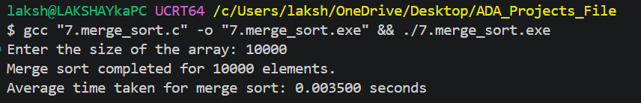
Table:
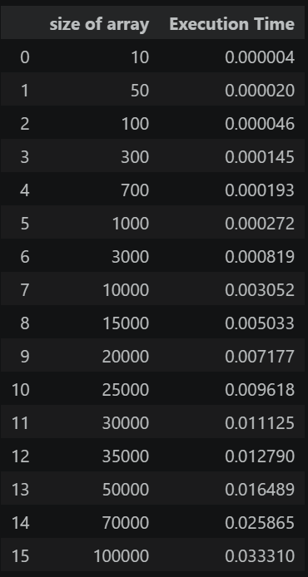
Graph:
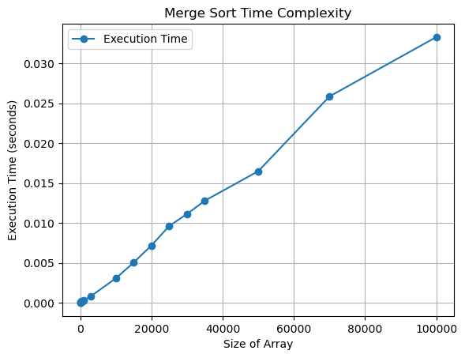

Conclusion:
The graph shows that the execution time of Merge Sort increases as the size of the array increases. The increase is relatively gradual and consistent, even as the array size grows up to 100,000 elements.
This behaviour is consistent with the theoretical time complexity of Merge Sort, which is O(n log n). The algorithm efficiently divides the array into smaller subarrays, sorts them, and then merges them.
Therefore, the experimental results support the theoretical conclusion that Merge Sort has an O(n log n) time complexity, making it more efficient than O(n²) algorithms such as Insertion Sort for large datasets.

